CSA05-DATABASE MANAGEMENT SYSTEMS
LAB OBSERVATION
EXPERIMENT:21
AIM:
To implement Space, Substr, Upper, Lower, Trim, LengthString Functionsusing MySQL.
SQL QUERIES:
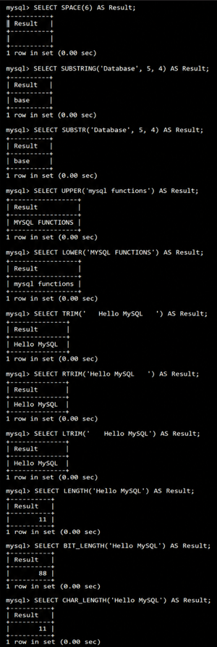

RESULT:
Thus the String Functionssuch asspace, substr, upper, lower, trim, length are executed successfully.

